*Certificate of Completion*

This is to certify that **Syed Mohammad Ali**

have successfully completed their ACCP Semester IV “E-Project”.

Submitted to: **Aptech Computer Education**

On

**May 26th, 2021**

*“Acknowledgement”*

First of all we would like to thank Almighty Allah for giving us strength and ability to complete this project.

And then, we would like to express my special thanks of gratitude to our teacher **Sir Moiz Hussain** who guided us on the project *FURNITURE Appliances*, which also helped us in doing a lot of new learning and we came to know about so many new things we are really thankful to him.

We are highly thankful to **Sir Moiz Hussain** for his guidance and constant supervision as well as for providing necessary information regarding the project & also for his support in completing the project.

Lastly, we would also like to thank our parents and friends who helped us a lot in finalizing this project within the limited time frame. We also express our sincere gratitude to E-Project team from Aptech Head Office, for their valuable guidance and support for the completion of this project. We earnestly hope that this project will provide all the necessary information required by the user to fulfill his/her inspiration. However, suggestion and Feedbacks for improvements will be thankfully welcomed & acknowledged*.*

# “Introduction”

The thirst for learning, upgrading technical skills and applying the concepts in real life environment at a fast pace is what the industry demands from IT professionals today. However busy work schedules, far-flung locations, unavailability of convenient time-slots pose as major barriers when it comes to applying the concepts into realism. And hence the need to look out for alternative means of implementation in the form of laddered approach.

The above truly pose as constraints especially for our students too! With their busy schedules, it is indeed difficult for our students to keep up with the genuine and constant need for integrated application which can be seen live especially so in the field of IT education where technology can change on the spur of a moment. Well, technology does come to our rescue at such times!!

Keeping the above in mind and in tune with our constant endeavour to use Technology in our training model, we at Aptech have thought of revolutionizing the way our students learn and implement the concepts using tools themselves by providing a live and synchronous eProject learning environment!.

# “Project Requirements”

# Food Wastage Management

In today’s world, we folks organize and go to so many events. There are various corporate events, meetings, functions and parties organized.

In these events, there are lots of food being wasted due to people’s preferences.

So, Why not we can develop a Mobile Application based on Food preferences and the number of people coming to the event.

**PROPOSED SYSTEM**

Event invitation to be sent to invitees on mobile app. Invitation will contain all the details related to the event. It will be supported with some beautiful graphics.

All invitees will be provided with complete details of the event. It could spread across pages/tabs. It will also provide the food options available along with the menu of food for the event.

It should also take input from the user in terms of their food preference, like Veg, Non-Veg, Continental etc. This will help to procure limited food for the event and in turn will help in reducing the wastage

* User need to give the details of event.
* It should allow use of maps for viewing the location.
* It will provide easy access to the event.
* It will also be very helpful for those people who are new to the city.
* Food preference will help organizers to procure required quantity of food.

**KEY FUNTIONALITY**

* Guest should be registered as User in the app.
* All guest should login using proper id/password.
* Food Preferences option will be provided to the Guests
* Report on Number of guests coming for the Event.
* Report on Food preferences of the participants.
* Better management for events and functions.
* Timing and Venue will be provided through Google Maps
* The dress code can be added for the event.

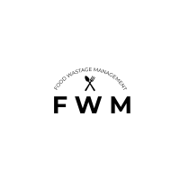

# Food Wastage Management

First start from the loading splash screen you see below here:



After 3 sec there is a appear of login section where multiple user can access their accounts to login in the application as well as whose user those have no accounts they can easily create their account by using Sign up option as you see in the picture:

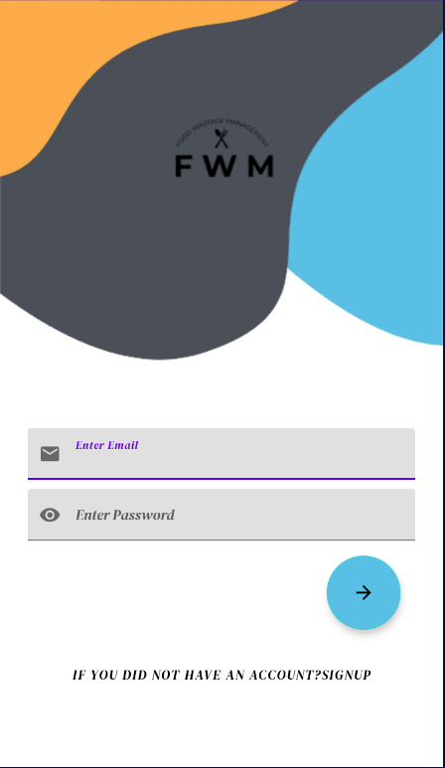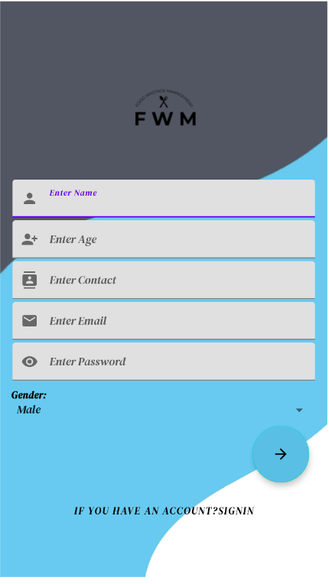

Now after the registration section user can easily login with email and password.

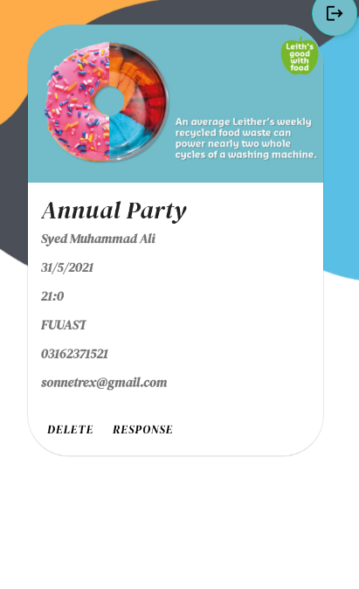

After login there is appear of event manager fragment where user see whole of event and response it with according to their suitability he/she can see the map and find and set location to and from where event held at. They easily response it with their name email and password.

Have a look;

response section take an idea to look;

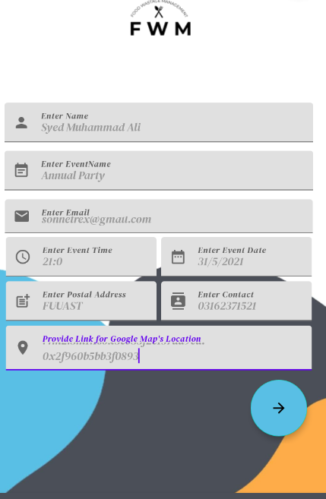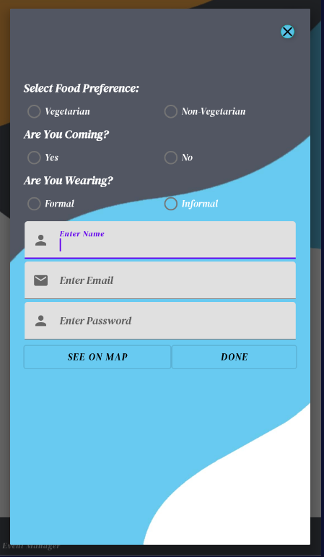

Create Event section where user can easily create an event for their own people to invite their guest

By filling the form look above at right corner.

Dialog to set Date, Time And location from Google map by tapping double click on the text field;

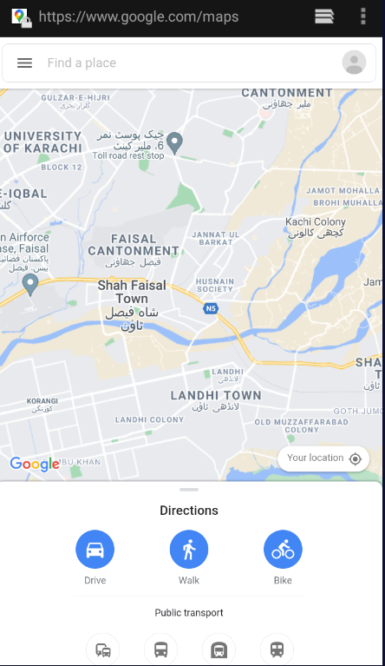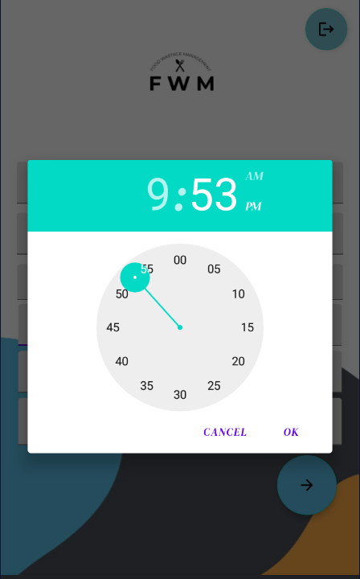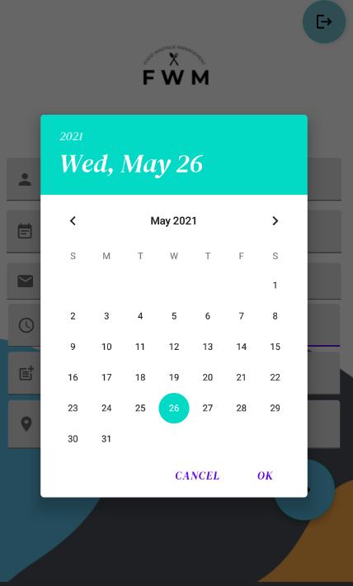

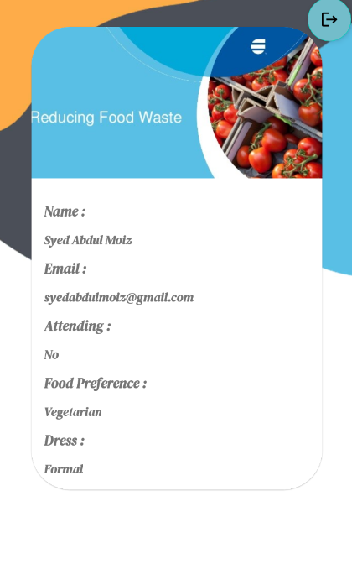There is a response section where user can see their event’s response ,

Those people response the event their information is shown in the

Response section now we estimate that they are coming on our event

Party or birthday ,etc.

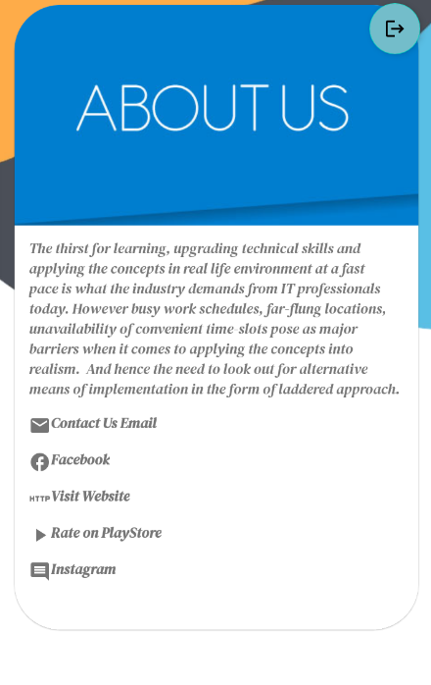

There is a about section where people can know about us or contact with us.